Prospects for the development of the transport and logistics network in the Chernivtsi region in the current conditions

Volodymyr KOSTASHCHUK ^{1*}  https://orcid.org/0000-0001-8351-4856 | UDC 911.3:316
Vitalii ZABLOTOVSKYI ^{2*} https://orcid.org/0009-0008-0984-7992 | ANALYTICAL ARTICLE

¹ Yuriy Fedkovych Chernivtsi National University,
Department of Geography of Ukraine and Regional Studies
² Yuriy Fedkovych Chernivtsi National University,
Department of Geography of Ukraine and Regional Studies

Correspondence – *v.kostaschuk@chnu.edu.ua
- *zablotovskyi.vitalii@chnu.edu.ua

Keywords: development strategy, transport and logistics networks, administrative-territorial structure, settlement system, transport routes, cross-border region, Chernivtsi region.

Abstract: The study of the transport and logistics network of the Chernivtsi region was prompted by considerable interest in the context of its cross-border location and existing problems in the functioning of the state's transport and logistics network as a whole, against the backdrop of military aggression. This study deserves special attention against the backdrop of the political situation in the border areas of neighbouring countries. The use of logistical links with Romania is now becoming strategic for Ukraine. Therefore, the article reveals the importance of Ukraine's entry into the Trans-European transport and logistics network, in particular the territory of the Chernivtsi region. Its advantageous geopolitical location has long been underestimated. Its proximity to two countries and the predominance of flat and foothill landscapes facilitate the development of international border crossing points. Its proximity to four regions with a sufficiently dense transport network and located at the intersection of national transport routes, as well as sufficient free space on its territory for the creation of logistics hubs. An existing transport complex that is ready for immediate use. One of the densest networks of motorways and railway lines among the regions of Ukraine, with railway junctions in Chernivtsi, Vadul-Siret, and Larga. There is an existing international airport within 30 kilometres of the border with Romania. All this has become the basis for the development of technical and economic recommendations to increase freight and passenger traffic in the direction of Lviv – Chernivtsi – Hlyboka – Vadul-Siret – Dornesti – Suceava. This will provide Ukraine with connections to the ports of Romania and Bulgaria and access to the Mediterranean and Adriatic Seas. All this will ensure that the Chernivtsi region plays an important role in Ukraine's transport and logistics links.

1. INTRODUCTION

At the current stage of Ukraine's economic development, the exchange of goods and services is indispensable. That is why the development of transport and the provision of transport services is an important area of scientific research in various fields of knowledge. This issue is of particular interest to geographers, as transport routes run across the territory and provide transport services. They transport people and the products they produce. And the question is no longer simply how to transport, but how to do so optimally, competently, in the shortest possible time and with the highest quality. All this will be influenced by a wide range of socio-geographical factors, as studied by geographers. On the path to Ukraine's integration into the European Union, the issue of transport and logistics relations has become even more relevant.
As for the transport and logistics network of the Chernivtsi region, it is of considerable interest in the context of its cross-border location and the existing problems in the functioning of the state's transport and logistics network as a whole, against the backdrop of military aggression. This study deserves special attention against the backdrop of the political situation in the border areas of neighbouring countries. The use of logistics links with Romania is now becoming strategic for Ukraine.

2. MATERIALS AND METHODS
The study of transport and logistics networks is carried out by scientists from various fields, including economists, managers and logistics engineers. Each of these areas is clearly important and practically significant. In his works in the field of logistics management, R. Moliboga analyses in detail the modern terminology used in the study of transport and logistics, noting that transport is one of the basic sectors of the economy, which determines all aspects of the development of the social and production infrastructure of a territory (Moliboga 2024). Of particular interest are studies analysing international experience in the development of transport and logistics activities in the context of the economic development of urban agglomerations (Pichugina, Kopylova & Shiryayeva 2024). No less important from a scientific and practical point of view is the monograph by a group of scientists from the Ivan Pul'uj Ternopil National Technical University, who conducted a substantive study of the international community's experience in the development and operation of transport and logistics centres and proposed recommendations for their creation in the regions of Ukraine (Aulin & Lyashuk 2024). The critical importance of transport and logistics activities in conditions of military aggression for Ukraine in general and for the border regions of our state in particular is highlighted in the works of K. Gnedita and K. Nahorny. They identified the main trends and prospects for the development of logistics infrastructure in the border regions of Ukraine during military aggression. They pointed out the consequences of a full-scale invasion for the provision of transport and logistics services, and most importantly, they pointed out the priority of developing transport and logistics networks in border regions, taking into account the specifics of modern challenges (Gnedina & Nagorny 2024).
However, as social geographers, we are interested not only in the economic and technical conditions and prospects of transport and logistics activities, but also in their specific features in relation to the geographical location of the territory and in combination with the functioning of the settlement system. First of all, it is worth noting a number of works by I. Smirnov, which reveal the main geographical components and prerequisites for the activities of transport and logistics clusters in Ukraine in line with European integration processes and the geospatial levels of logistics systems (Smirnov 2010), (Tsyganok & Smirnov 2015). A group of authors from Lviv and Kyiv examined the essence of the concept of a transport and logistics system and the main areas of activity of transport and logistics enterprises in modern conditions. They also outlined the main problems that have arisen in the activities of Ukraine's transport and logistics system in the current reality (Vykliuk, Petlin, Petlin & Yakymovych 2024). Using the example of the Odessa region, Nefedova N. E. conducted socio-geographical research on the development of transport and logistics networks and systems (Nefedova 2014). Also important in the context of our topic is the research by I. Lutsenko, who proposes the development of logistics clusters within the framework of cooperation with European logistics networks (Lutsenko 2021).
Our research is based on an analysis of regulatory documents, Ukrainian laws, information from the official website of the Ministry of Community and Territorial Development of Ukraine, and the Chernivtsi Region Development Strategy until 2027.

3. RESULTS
The development of transport and logistics networks is contingent on the general characteristics of the region. The aforementioned factors include the area of the region under study, population size, level of urbanisation, population density, and so forth. While these indicators appear to have no discernible impact on transport networks, a retrospective analysis reveals that they were, in fact, instrumental in shaping the region's contemporary transportation infrastructure. The existing transport networks in the Chernivtsi region were formed in the process of economic development of the region and therefore pass through populated areas, providing systemic connections. The correlation between the presence of transport routes and the subsequent development of settlements can be traced by examining the genetic types of settlements. For instance, the cities of Chernivtsi and Khotyn were founded as defensive cities on trade routes (Zablotovska & Leiberyuk 2013). As time passed, settlements located along regional and international transport routes began to stand out in the region's settlement system. These settlements began to perform the functions, if not of transport centres or hubs, then of social and economic centres dependent on transport links. The greater the number of functions performed by the population, the larger its size will be, and accordingly, the wider the range of services. At the present stage, qualitative changes are taking place in areas where there is demand for transport and logistics services – in populated areas. Transport characteristics will also be contingent on general indicators.
The transport and logistics advantages of the territory are an important factor in its future development. After all, the modern development of territories depends largely on their favourable transport location. This can be seen both in the population density of settlements and in their level of socio-economic development. This is especially true if these advantages are reinforced by a favourable geopolitical location. The transport network of the Chernivtsi region, taking into account the peculiarities of its geographical location, combines linear and radial scenarios of formation and is developing qualitatively due to the improvement of the quality of transport links. Transport hubs are formed taking into account their distance from the regional centre and administrative significance. An important stage in the modernisation of the region's transport and logistics system was the changes in the administrative-territorial structure of the region. The creation of three districts in the region also involves a review of the logistical roles of the region's settlements. And if Chernivtsi and Vyzhnytsia clearly stood out in terms of transport in their development under the old administrative-territorial structure (and in genetic terms), then Kelmentsi has to form this role for the first time, since previously the current administrative centre of the Dniester district lagged somewhat behind in terms of the number and importance of functions performed between neighbouring Khotyn, Sokyryany, and Novodnistrovsk.
Another important factor that will undoubtedly have a significant impact on the development of both the region's transport system and the functioning of transport and logistics networks is Ukraine's current geopolitical situation. Although the importance of the region's cross-border location has always been duly appreciated by the regional leadership in its multifaceted activities, new horizons became all too clear in the early days of the full-scale invasion, when long queues first formed at the operating checkpoints with IDPs and later with representatives of transport companies. This caused significant logistical, economic and environmental problems that required urgent solutions.
In parallel with the reformatting of the region's socio-economic activities under martial law, the problems of logistical connections became clear to both Ukraine and our international partners, which led them to review the main directions of international transport and logistics corridors and identify urgent tasks for investment and reconstruction of Ukraine's transport and logistics network. The most important for our European partners is the Trans-European Transport Network (TEN-T), which was created in the EU with the aim of connecting European countries with a network of motorways, railways, waterways, pipelines and airports (Fig. 1). Ukraine joined TEN-T in 2017 in accordance with the European Commission's investment plan (Official EU website 2025).
However, in connection with the events of 2022, changes were made that specifically affect the territory of the Chernivtsi region (Official website of the Ministry of Community and Territorial Development of Ukraine 2025). The integration of the TEN-T transport system with the Ukrainian network will take place in two stages: completion of the ‘core’ network by 2030 and the ‘comprehensive’ network by 2050 (Investment Map of Ukraine 2025).

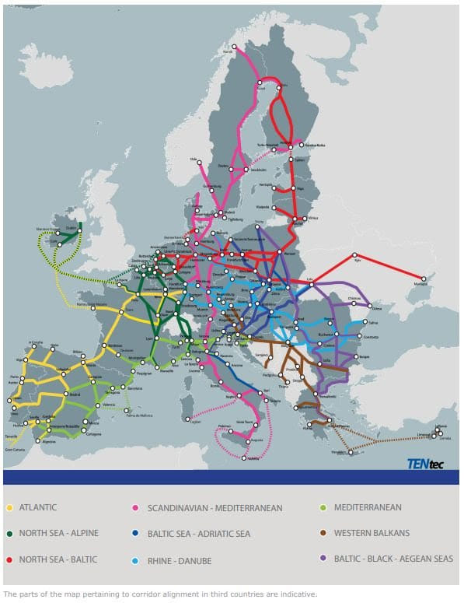

Fig. 1 Diagram of European transport corridors (Official website of the publication Economy of Ukraine 2022)

For Ukraine, this decision is of strategic importance, both for integration into the EU and as a factor that will contribute to the implementation of the ‘Solidarity Routes’ project initiative. Among the changes affecting the Chernivtsi region, it is worth noting the reformatting of the directions and organisation of the activities of the ‘Baltic-Black Sea-Aegean’ corridor, which has been extended through Lviv, Chernivtsi, Romania and Moldova towards Odesa (Chernivtsi Region Development Strategy 2027).
The integration of Ukrainian national logistics routes into the TEN-T network makes it possible to remove existing obstacles to logistics operations (both civil and military), attract European investment for the modernisation of transport infrastructure (since the logistics network is already in use, and its poor condition negatively affects the cost of logistics services), reduce logistics costs and improve the quality of logistics services in the transport of goods (Topchiev, Kolomiets, Sych & Yavorska 2024).
A good example of the importance of transport and geographical location is the Chernivtsi region. For this region, this factor is even highlighted as the first strength in the SWOT analysis of the Chernivtsi region's development (Chernivtsi Region Development Strategy 2027). It is also worth noting that the advantages of the region's geographical location have led to the formation of the first, second and fifth points among the identified opportunities for the development of the Chernivtsi region in the same SWOT analysis. These opportunities for the regional authorities are related to the growth of the region's transit potential as a result of the inclusion of the region's territory in the European transport network TEN-T and, accordingly, its transport artery VIA CARPATIA (Official website of the Ministry of Development of Communities and Territories of Ukraine 2025). The Trans-European Transport Network is an important transport and logistics facility of the European Union, and being part of it is a significant advantage for the development of the region. After all, joining such a powerful international project will not only bring investment in the development of the region's transport network, but also lead to growth in socio-economic potential. The Chernivtsi region, which on the one hand is peripheral and remote from Ukraine's main transport routes, but on the other hand borders two of Ukraine's partners and has a relatively stable security situation, could become a new promising transport and logistics hub. Given the need for a rapid response from the international community to the conditions of cooperation during a period of military aggression practically in the centre of Europe, a logical solution was to review the directions of the main international transport corridors. In particular, within Ukraine, it was extended through Lviv, Ternopil to Chernivtsi, through Romania towards Bulgaria and Moldova towards Odesa. In this case, the geographical location of the Chernivtsi region played a decisive role in the planning of such corridors.
Neighbourhood with two countries, predominantly flat and foothill landscapes, which facilitates the development of international border crossing points. Neighbourhood with four regions that have a sufficiently dense transport network and are located at the intersection of national transport routes, with sufficient free space on the territory for the creation of logistics hubs. An existing transport complex that is ready for immediate use. One of the densest railway networks among the regions of Ukraine, with railway junctions in Chernivtsi, Vadul-Siret, and Larga. There is an existing international airport within 30 kilometres of the border with Romania. All this has become the basis for the development of technical and economic recommendations to increase freight and passenger traffic in the direction of Lviv – Chernivtsi – Hlyboka – Vadul-Siret – Dornesti – Suceava. This will provide Ukraine with connections to the ports of Romania and Bulgaria and access to the Mediterranean and Adriatic Seas (Fig. 2).
Given its geographical location and small area, the Chernivtsi region has a contradictory transport network. It has one of the highest densities of paved roads, but until 2022, it will have relatively low passenger and freight traffic. The railway network remains at 2003 levels, but has significant potential for international transport. Another positive factor is the location of the international airport within 30 kilometres of the state border. Together with the region's rich tourism and recreational potential, the region has a strong foundation for the development of a transport and logistics network that will integrate international flows for both freight and passenger transport.
Currently, there are 6 customs posts and 16 checkpoints operating in the Chernivtsi region. Their presence is an important factor in the socio-economic development of both the region as a whole and the communities where they are located. After all, the functioning of facilities of international logistical importance also requires the presence of road, social, hotel and restaurant infrastructure. This will have a positive impact on the formation of the demographic potential of communities, which is why it has been taken into account in the development of development strategies for both the region as a whole and the individual communities in which they are located.

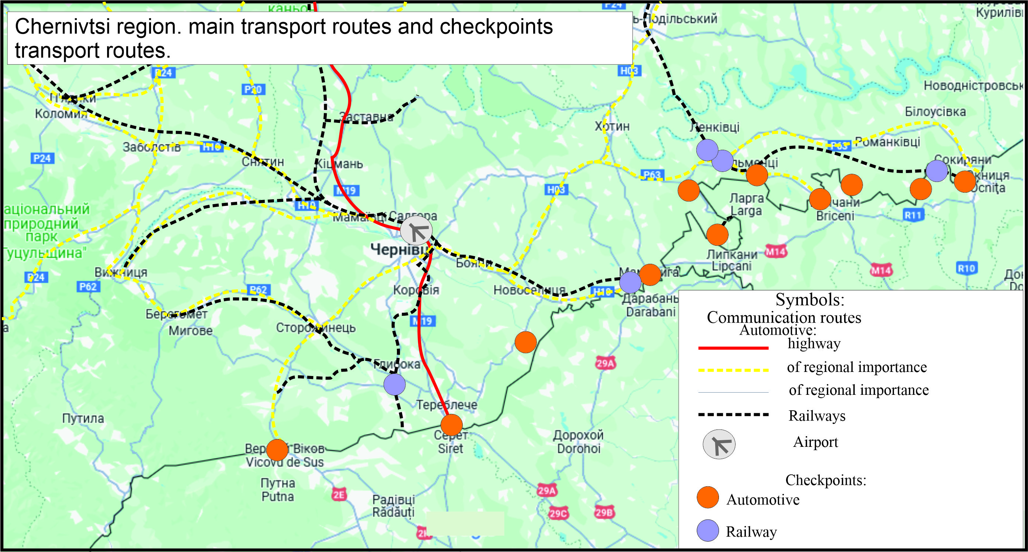

Figure 2. Main elements of the transport and logistics network of the Chernivtsi region.

Given these circumstances, the decision to review the directions and capacities of the main logistics routes in Ukraine presented both a new opportunity and a new challenge for the Chernivtsi region. After all, large volumes of goods need to be transported, but the technical condition of the transport infrastructure is not ready for such a load. The long-term underfunding of the road sector has become perhaps the first challenge, manifested in poor road surfaces, geological features of the territory, and the long-term absence of repair work, combined with additional loads, have caused damage and collapses of railway tracks, as well as the worn-out and obsolete condition of rolling stock. Airport infrastructure, the arrangement of international checkpoints, and the insufficient number of high-quality storage facilities all require reconstruction or construction in accordance with international standards. The growth in the volume of domestic and international transit traffic has revealed the problem of a lack of logistics terminals with high-quality equipment for transhipment and storage of cargo. This problem is relevant not only for Ukraine, but also for Romania and Moldova, as our neighbours were also unprepared for the growth in transport and logistics activity on the border with the Chernivtsi region.
In parallel with the activities within the framework of the ‘Great Construction’ and ‘Roads of Solidarity’ projects and the reconstruction of transport networks, work is also underway in neighbouring Romania to expand their logistics capabilities. The construction of a motorway north of Bucharest through Suceava to Siret is almost complete, where the construction of a logistics hub and a connection to the Ukrainian M19 motorway is also planned.
Taking into account these points, realizing the need and urgency of addressing the above issues, and having realistically assessed all the threats that may arise in this context of the region's economic development, the Chernivtsi Region Development Strategy until 2027 (Chernivtsi Region Development Strategy 2027) in Strategic Objective 2 "Spatial Development of the Territory and Infrastructure" has set aside a separate Operational Objective "Ensuring the Development of the Region's Transport and Logistics Infrastructure" as an operational goal. To achieve this goal, six tasks were identified with step-by-step development of ways to implement them. All of them address a particular problem area, although ultimately they will not only address Ukraine's urgent needs for strategic cooperation with international partners, but will also contribute to the further socio-economic development of Chernivtsi region.
In parallel, the region has begun work on developing project documentation for the construction of new communication routes (connecting Chernivtsi with Kamianets Podilskyi by rail) and transport infrastructure, reconstruction of existing roads and railways (including alignment with European standards for railways from Chernivtsi to Vadul Siret), and opening new rail routes. It is equally important to resolve the issue of bus passenger transportation and optimize public transport in the regional center, which is also a tourist attraction in Ukraine. Active work is underway to develop border infrastructure to ensure smooth international traffic. New checkpoints and access roads to them have been opened and are being built, and service zones have been opened to simplify and speed up customs control, which has helped to relieve both the existing ones and solve the problem of border crossing delays (which was observed in the first two years of full-scale aggression). To serve the growing volumes of domestic and foreign transit traffic, it is planned to build multimodal logistics terminals in border communities and on the territory of Chernivtsi City Council, which will improve the quality and reduce the cost of transportation.

4. DISCUSSION
As we can see from the example of the Chernivtsi region, a favorable geopolitical location is an important factor not only for the socio-economic development of states, but also of regions. In this context, the formation of cross-border transport and logistics clusters within the cross-border districts of Chernivtsi region and neighboring counties of Romania will be promising, which will not only increase the efficiency of using their transit potential, but also ensure its increase. The task of reconstructing the runway of the Chernivtsi International Airport and reconstructing its infrastructure to bring its conditions in line with international standards deserves special attention.
Today, both in the region and in Ukraine, mainly logistics facilities are being built, which determine the location of logistics centers in and around the regional center, where consumer demand is the highest. However, with the revision of the directions of pan-European logistics corridors and the development and expansion of small and medium-sized businesses, the demand for local logistics facilities will grow. For example, newly created district centers have already seen the emergence of branches of logistics companies or low-level transport and logistics companies that mainly use small warehouse facilities but supply the district. Increased activity of international logistics services will help to improve the economic situation and boost demand. With the combination of transport and logistics potential and political prerequisites, it will be possible to achieve the full realization of the transit potential of Chernivtsi region and ensure an improvement in the level of economic security of our country.

5. CONCLUSIONS
Currently, despite the war in Ukraine, favorable conditions have been created for the development of transport and logistics networks in the Chernivtsi region. Having analyzed the problems and projected the prospects for the development of the transport and logistics network of the Chernivtsi region, we can say with certainty that quite favorable conditions for the development of the transport and logistics business have been formed in the Chernivtsi region. Among them is the formation of a network of cross-border logistics clusters on the border of Chernivtsi region with Romania, which is an important factor in the integration of our country into the system of world economic relations, as well as a significant incentive for the European integration of the region. The functioning of cross-border transport and logistics networks will not only improve the quality of transportation, but also the transport infrastructure.

REFERENCES
- Віклюк, M., Петлін, I., Петлін, K., & Якимович, A. (2024) Проблеми розвитку транспортно-логістичної системи України в сучасних умовах. Формування ринкової економіки в Україні, (51), 105-114. [Vikliuk, M., Petlin, I., Petlin, K., & Yakymovych, A. (2024) Problemy rozvytku transportno-lohistychnoi systemy Ukrainy v suchasnykh umovakh. Formuvannia rynkovoi ekonomiky v Ukraini, (51), 105-114.] DOI: http://dx.doi.org/10.30970/meu.2024.51.0.5112
- Аулін, В. В., Митник, М. М., Ляшук, О. Л., Гевко, І. Б., Цьонь, О. П., Лисенко, С. В., ... & Бабій, М. В. (2024). Формування та функціонування логістичних центрів в регіональних транспортно-логістичних системах України, 393. [Aulin, V. V., Mytnyk, M. M., Liashuk, O. L., Hevko, I. B., Tson, O. P., Lysenko, S. V., ... & Babii, M. V. (2024). Formuvannia ta funktsionuvannia lohistychnykh tsentriv v rehionalnykh transportno-lohistychnykh systemakh Ukrainy, 393.]
- Заблотовська, Н. В., & Лейберюк, О. М. (2013). Територіальні відміни розселення населення у Чернівецькій області. Науковий вісник Чернівецького університету. Географія, (672-673), 89-91. [Zablotovska, N. V., & Leiberiuk, O. M. (2013). Terytorialni vidminy rozselennia naselennia u Chernivetskii oblasti. Naukovyi visnyk Chernivetskoho universytetu. Heohrafiia, (672-673), 89-91.]
- Луценко, І. С. (2021). Євроінтеграція як чинник розвитку транспортно-логістичних кластерів в Україні. Підприємництво та інновації, (16), 67-70. [Lutsenko, I. S. (2021). Yevrointehratsiia yak chynnyk rozvytku transportno-lohistychnykh klasteriv v Ukraini. Pidpryiemnytstvo ta innovatsii, (16), 67-70.]
- Молибога, Р. (2024). Методологічні принципи управління ефективністю транспортно-логістичної системи. Публічне управління: концепції, парадигма, розвиток, удосконалення, (9), 91–98. [Molyboha, R. (2024). Metodolohichni pryntsypy upravlinnia efektyvnistiu transportno-lohistychnoi systemy. Publichne upravlinnia: kontseptsii, paradyhma, rozvytok, udoskonalennia, (9), 91–98.]
- Нефедова, Н. Є. (2014). Суспільно-географічні дослідження транспортно-логістичних мереж та систем. Вісник Одеського національного університету. Серія: Географічні та геологічні науки, (19, Вип. 3), 107-114. [Nefedova, N. Ye. (2014). Suspilno-heohrafichni doslidzhennia transportno-lohistychnykh merezh ta system. Visnyk Odeskoho natsionalnoho universytetu. Seriia: Heohrafichni ta heolohichni nauky, (19, Vyp. 3), 107-114.]
- Пічугіна, Ю., Копилова, О., & Ширяєва, Л. (2024). Міжнародний досвід розвитку транспортно-логістичних систем в міських агломераціях. Економіка та суспільство, (63). [Pichuhina, Yu., Kopylova, O., & Shyriaieva, L. (2024). Mizhnarodnyi dosvid rozvytku transportno-lohistychnykh system v miskykh ahlomeratsiiakh. Ekonomika ta suspilstvo, (63).]
- Смирнов, І. Г., & Косарева, Т. В. (2010). Геопросторові рівні логістичних систем та чинники їх формування, 1-3. [Smyrnov, I. H., & Kosareva, T. V. (2010). Heoprostorovi rivni lohistychnykh system ta chynnyky yikh formuvannia, 1-3.]
- Топчієв О. Г., Коломієць К. В., Сич В. А., & Яворська В. В.(2024) Геопросторова цілісність земної оболонки: методологія дослідження: Навч. посіб. Одеса: Одес. нац. ун-т ім. І. І. Мечникова, 2024, 303. [Topchiiev O. H., Kolomiiets K. V., Sych V. A., & Yavorska V. V.(2024) Heoprostorova tsilisnist zemnoi obolonky: metodolohiia doslidzhennia: Navch. posib. Odesa: Odes. nats. un-t im. I. I. Mechnykova, 2024, 303]
- Топчієв, О. Г., & Сич, В. А. Геопросторова цілісність земної оболонки: предметна область географії. In Географічна наука та освіта: перспективи й інновації: зб. матеріалів ІВІ Міжнар. наук.-практ. конф., Переяслав, 19-20 жовт. 2023 р./[редкол.: Коцур ВВ, Руденко ЛГ, Маруняк ЄО та ін.], 209. [Topchiiev, O. H., & Sych, V. A. Heoprostorova tsilisnist zemnoi obolonky: predmetna oblast heohrafii. In Heohrafichna nauka ta osvita: perspektyvy y innovatsii: zb. materialiv IVI Mizhnar. nauk.-prakt. konf., Pereiaslav, 19-20 zhovt. 2023 r./[redkol.: Kotsur VV, Rudenko LH, Maruniak YeO ta in.], 209.]
- Циганок, М. Л., & Смирнов, І. Г. (2015). Географічні особливості транспортно-логістичних кластерів в Україні в контексті євроінтеграційних процесів. Географія та туризм, (33), 150-159. [Tsyhanok, M. L., & Smyrnov, I. H. (2015). Heohrafichni osoblyvosti transportno-lohistychnykh klasteriv v Ukraini v konteksti yevrointehratsiinykh protsesiv. Heohrafiia ta turyzm, (33), 150-159.]

інформаційні ресури
- Інвестиційна карта України (2025). [Investytsiina karta Ukrainy (2025)] Джерело
- Офіційний вебсайт Європейського союзу (2025). [Ofitsiinyi vebsait Yevropeiskoho soiuzu](Джерело
- Офіційний сайт видання Економіка України (2022). [Ofitsiinyi sait vydannia Ekonomika Ukrainy (2022)] Джерело
- Офіційний сайт Державної прикордонної служби України (2025). [Ofitsiinyi sait Derzhavnoi prykordonnoi sluzhby Ukrainy (2025)] Джерело
- Офіційний сайт Міністерства розвитку громад та територій України (2025). [Ofitsiinyi sait Ministerstva rozvytku hromad ta terytorii Ukrainy (2025).] Джерело
- Стратегія розвитку Чернівецької області до 2027. [Stratehiia rozvytku Chernivetskoi oblasti do 2027] Джерело

В. Костащук, В. Заблотовський
Перспективи розвитку транспортно-логістичної мережі в Чернівецької області у сучасних умовах

Ключові слова: стратегія розвиту, транспортно-логістичні мережі, адміністративно-територіальний устрій, система розселення, шляхи сполучення, транскордонний регіон, Чернівецька область.

Анотація:.
Проведене дослідження транспортної логістичної мережі Чернівецької області, зумовлене неабияким інтересом в контексті транскордонного розташування та наявних проблем у функціонуванні транспортно-логістичної мережі держави в цілому, на фоні військової агресії. Окремої уваги заслуговує дане дослідження й на тлі політичної ситуації, що склалася в прикордонних ділянках сусідній країн. Й використання логістичних зв’язків із Румунією наразі стає стратегічним для України. То ж в статті розкрито значення входження України до Транс Європейської транспортно-логістичної мережі, зокрема території Чернівецької області. Вигідне геополітичне розташування якої тривалий час було недооцінене. Сусідство із двома державами, переважання рівнинних та передгірських ландшафтів, що сприяє розбудові створенню міжнародних пропускних пунктів. Сусідство із чотирма областями які мають достатньо густу транспортну мережу та знаходяться на перетині транспортних шляхів національного рівня, достатньо вільних приміщень на території для створення логістичних хабів. Сформований наявний транспортний комплекс який готовий до негайного задіяння. Одна із найбільш щільних мереж автомагістралей та залізничних колій серед областей України, із залізничними вузлами Чернівці, Вадул-Сірет, Ларга. Наявний діючий міжнародний аеропорт в 30-ти кілометровій зоні до кордону із Румунією. Все це стало підґрунтями для роботи по розробці техніко-економічних рекомендацій для збільшення вантажо- та пасажиропотоків у напрямку Львів – Чернівці – Глибока - Вадул-Сірет – Дорнешт – Сучава. Цим самим забезпечивши для України з’єднання із портами Румунії, Болгарії та виходу до Середземномор’я та Адріатики. Все це забезпечить для Чернівецької області вагоме місце у транспортно-логістичних зв’язках України.
Керівництво Чернівецької області зацікавлене у розвитку даного напрямку економічного розвитку території, тому приділило значну увагу розвитку транспортно-логістичного спрямування у Стратегії розвитку Чернівецької області до 2027 року. Для цього виокремлено шість завдань із покроковою розробкою шляхів їх реалізації. Усі вони забезпечують вирішення того чи іншого проблемного напрямку, що в кінцевому результаті забезпечать не лише вирішення нагальних потреб України щодо стратегічної співпраці із міжнародними партнерами, але й сприятимуть подальшому соціально-економічному розвитку Чернівецької області.

